

**JINJA JOINT EXMAINATIONS BOARD**

**273/2 GEOGRAPHY**

**MARKING GUIDE 2022**

**QUESTIONS**

1. (a)

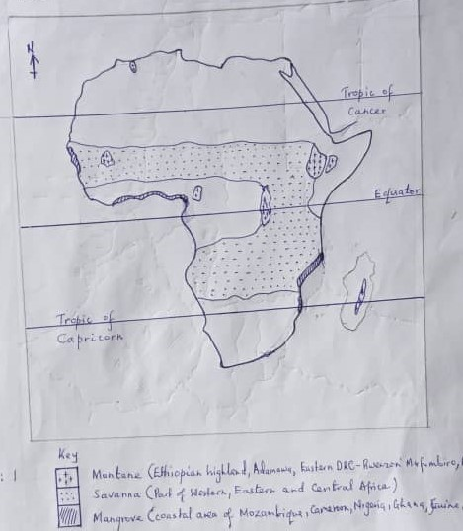

(b) Description of characteristics of:

**EITHER:**

**SAVANNAH VEGETATION: TYPE**

* Grasses dominate; which include spear and elephant grasses that are green during the wet season and become brownish during the dry season.
* Grasses mainly very tall of over two meters, close to the tropical rainforest.
* Grasses reduce in height; towards the margins of the desert/Sahel region; shrub-like and common species are acacia.
* Presence of scattered trees; punctuating the grass land; e.g. acacia, baobab i.e. xerophytic.
* Trees are deciduous; and therefore shed off their leaves during prolonged dry season so as to reduce on excessive transpiration.
* The structure of leaves are very small, waxy and sometimes thorny – like; this also helps in reducing excessive water loss.
* Trees have long roots that extend deep into the ground; so as to tap underground water and plant nutrients.
* Trees have thick barks; so as to reduce moisture loss, protection against drought fires.
* Trees are of medium height; due to the moderate conditions of soil, climate etc.
* Trees are thorny bushes; to scare away herbivores.
* Trees have twisted trunks/not straight; caused by exposure to vagaries like fire, drought, and inadequate soil nutrients.
* Hard wood trees; due to inadequate moisture and long gestation period.
* Mixed stand; acacia, baobab etc.
* Grasses exist in compact tufts; close to the Sahel and dense near the equatorial rain forest.
* Trees are umbrella shaped with single canopy; trap light, create shed.
* Some trees store water e.g. baobab which thrive closer to the desert.

**OR:**

**MANGROVE VEGETATION TYPE;**

* Have ability to grow on tide washed mud flats in the tropics.
* They gradually extend sea ward to further mud accumulation between their roots.
* Trees have short stumpy trunks supported by aerial roots or by roots which bend at right angles.
* The trees have a long gestation period, resulting into formation of hard wood.
* Trees are broad leaved to allow releases of excess moisture and ever green because they are moisture laden.
* They arrange themselves parallel to the coast enjoying the sea water nutrients.

**Illustration of montane vegetation zonation.**

1. (c) Explain the conditions which have led to the growth of the vegetation given in (b) above.

**EITHER: SAVANNAH VEGETATION TYPE.**

* Low rainfall amounts (500 – 960mm) annually that lead to the growth of grasslands and scattered trees.
* Prolonged dry season that hinders the growth of tall trees. Savannah trees are very short ranging between 6 – 12 meters in height.
* Hot temperatures for most of the year of about 270c on average that limit the growth of a luxuriant vegetation with tall trees they therefore favour short trees and short grass growth.
* Low humidity especially during the dry season favours the growth of grassland. This leads to high rates of evapo-transpiration thus limiting the growth rates of trees.
* Latitude between 50 – 150 North and South of the Equator favours the growth of savannah grassland.
* Human activities like agriculture, mining, charcoal burning lead to destruction of the woodland that are eventually transformed into grasslands.
* Presence of wild animals like elephant, giraffes graze, strip and trample upon the woodlands and turn them into savannah grassland vegetation.
* Fairly fertile soils like latosels are conducive for the growth of woodland and savannah; stunted and fire resistant.
* High incidence of pests like locusts that feed on the trees and grass.

**OR:**

**MOUTANE VEGETATION TYPE:**

Altitude plays the major role in this vegetation zonation.

* At 1000m – 1800m above seal level, savannah vegetation: grass – land and woodland, because at this altitude there in low rainfall amount of less than 750mm, low humidity, hot temperatures, fairly fertile soils, human interference like settlement.
* This is followed by savannah woodland due to; moderate rain fall of about 1000mm, hot temperatures of 220c – 290c, moderate humidity, fairly fertile soils, less human interference, well-drained soil.
* Between 2000m – 2500m above sea level rain forest exist due to heavy rainfall (1500mm – 2000mm), hot temperatures of about 270c, deep fertile soils, less human interference well drained soils.
* Between 2500m – 3500m above sea level, temperate forests exist; due to reducing rainfall total, cool temperature, shallow thin soils, well drained soils.
* Between 3500m – 4500m above sea level, heath and moorland exist; due to cold/cool temperature, extremely low rain fall or no rainfall, very thin soils, water logged soils due to melting of snow.

**OR:**

**MANGROVE: VEGETATION TYPE;**

* Ability to grow on tide washed mud flats.
* Continuous deposition of mud by rivers.
* Less stormy ocean currents that allow steady accumulation of mud i.e. rate of deposition is more than that of removal.
* Sheltered creek, lagoons, harbour;
* Wide and shallow continental shelves;
* Areas should be receiving water from an area of heavy rainfall.

1. (d) **Negative effects** mainly from the destruction of natural vegetation cover in Africa.

* Disappearance of valuable tree species due to clearance for timber and agriculture.
* Transformation of vegetation from natural to secondary species that are dangerous or inhibit movement of tourists.
* Leads to soil erosion because of removal of cover.
* Reduces soil fertility due to loss of water.
* Deforestation leads to desertification i.e. increase in temperature and decrease in rain fall.
* Leads to global warming.
* Increases strength of winds, increases its destruction
* Leads to prolonged drought and reduced rainfall.

1. (a)

A BAR GRAPH: NUMBER OF PEOPLE WORKING IN THE FISHING SECTOR FOR SELECTED AFRICAN COUNTRIES.

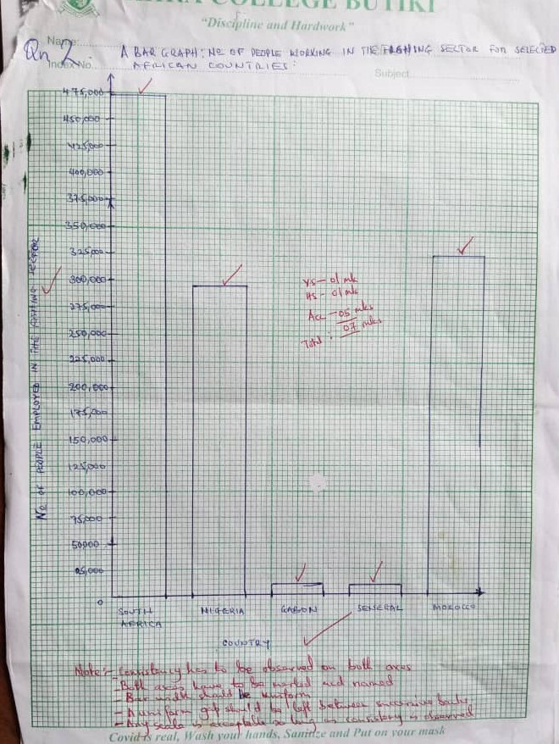

**NOTE:** Bars have to be spaced; no spacing, no mark for accurancy and horizontal scale. Only 1 mark for vertical axis.

1. (b) (i) Most dominant – South Africa (01 mark)

(ii) Least dominant – Senegal (01 mark)

(c) Name of Country (01 mark)

* Presence of large quantities of fish of commercial value; Sardine, Pilchard.
* Enhanced research is carried out to improve fishing activities; harvesting, preservation, marketing
* Availability of both skilled and semi-skilled labour; from home and abroad raising profits to work.
* Availability of adequate capital from state and foreign investors; to invest in fishing activities e.g. fishing, marketing.
* Modern fishing method like use of gillnet, trawling that promote; efficiency and increased fish catch.
* Availability of large market; for fish both at home and abroad raising profits.
* Favorable climatic conditions of warm/moderate temperature; ideal for fish to thrive – metabolism.
* Existence of large continental shelf with relatively deep water; for the spawning and growth of fish stock and effective fishing activity.
* Availability of adequate food/plankton for the fish; to feed on.
* Political stability/security in the country; promoting confidence over life and fishing gears hence increased fishing activities.

**NOTE:** **Place name, names of features must be captured for illustration.**

S. Africa – Johannesburg, Cape Town; Banguela and Mozambique currents; railway, (Cape Town – Pretoria); Indian and Atlantic oceans.

Nigeria – Lagos, Kano; R. Niger; Over 100m pop, Guinea current; Atlantic Ocean

Gabon – Atlantic Ocean; Port Gentile; Libreville.

Senegal – Canary current; Desert, Dakar

Morocco – Long coast line; Rabat; Algeria, cool canary current.

Id - max 3

ds - max 3 max 06

(d) (i) Explanation of the contribution of the fishing sector in any one country given in

the table.

* Source of food; rich in protein, i.e. body building.
* Enhances or stimulates research; in fishing related activities e.g. harvesting/catching, processing, marketing.
* Source of employment; to people raising incomes and hence standard of living.
* Diversification of the economies; reducing over – dependence on mining, forestry.
* Encouraged infrastructural development; e.g. roads, railways hence raising soil.
* Source of income; that improve people’s standard of living.
* Source of government revenue; through taxes, used to establish infrastructure, raising standard of living.
* Boosts international relationship with trade partners; promoting tourism, trade, security.
* Source of foreign exchange; through exportation of fish, used to import essentials.

1d – max 3marks

ds – max 3marks

(d) (ii) Outline of steps being taken to promote the fishing sector in the country chosen in

(c) above. (03 mks)

* Widening market through extensive advertisement to foreign market.
* Introducing better/modern fishing methods e.g. trawling, purse seining, etc.
* Forming local cooperatives to raise capital jointly; to use to buy fishing gears.
* Attracting skilled foreign workers; to raise the efficiency in management, of the sector.
* Developing transport routes like roads hence promoting marketing, production.
* Establishing fish processing factories to add value; hence profits.
* Investment in the industry by government, foreigners to expand the sector.
* Reducing the level of taxes to affordable levels raising profit margin to fishermen.
* Treating industrial wastes before dumping it in water, saving fish stock etc.

**NOTE;** - Observe the tense used in the question text …being…

* Use of should automatically invalidate the given points (09 marks)

**NOTE:** For outline no mark(s) should be awarded to a candidate that presents sweeping statements i.e. single words, incomplete statement. (25 marks)

1. (a) (i) towns marked:
2. Cairo
3. Port Sudan
4. Omdurman/Khartoum (03 marks)

(ii) Land forms:

A: Ethiopian Highland

B: Great Rift Valley (02 marks)

(iii) Irrigation scheme marked C: Gezira/manakal/ kenana (01 mark)

(iv) Lake marked D: Tana (01 mark)

(v) Country E: Djibouti (01 mark)

(08 MARKS)

(b) Describe (i) With specific examples, the physical factors which have favoured the establishment and development of the irrigation scheme marked in (a) (ii) above.

* The arid climate around the Gezira scheme is characterized by hot/high temperatures (over 200c) that quickens the maturing and ripening period of crops.
* The Gezira plains are generally flat favouring mechanization as well as water flow in the irrigation canals enabling large scale farming.
* Presence of fertile alluvial soils in the Gezira plain deposited by the Blue and White Nile have encouraged the growth of a variety of crops.
* Abundant water from Blue and White Nile for irrigation – variety of crops.
* Cheap large tracts of land along the Gezira: Managil and Kenana extension.
* Limited vegetation due to drought Sahara desert promotes easy clearing and avoid water logging.
* Gezira plains have deep water table such that the water logging does not occur which favours the growth of crops like cotton, sugarcane.
* Hard basement rock for dam construction sennar Jabel Aulic dams.

1d – max 2

Ds – max 2

3 (b) (ii) any one method of irrigation used on the irrigation scheme marked in (a) (ii) above.

**Either**: Perennial/Gravity method – Where the canals, ditches and channels are dug linking up the farm land to the water source. Irrigation is throughout the year, done at low or flat land.

**OR:** Archimedean screw method: - Is where a water pipe is fastened on a motor – like stand with perforated coil on the top. The spreading of water in the cultivable land is determined by the acceleration pressure of the water. Done at raised farmland.

**OR:** Overhead lining method: - Is where perforated pipe (s) is elected higher than the basic crop height and well distributed in the irrigation land. When the water is released, it finds its way into the farmland through the outlets on the raised pipe. The system has the distributor pipe, sprinkler supply pipe, control head (value, filter and pressure regulator). Done at raised farmland and undulating land.

**OR**: Drip irrigation – this is where a variety of distribution pipe lines that are evenly spread on the ground in a farm land are attached to a main supply that drips water at a slow rate.

Any one method. (01 mark)

Processes for a given method max (03 marks)

Subtotal (08 Marks)

3 (c) Explain the benefits of the irrigation scheme to the people living on the irrigation scheme;

* Employment opportunities have raised people’s Standards and incomes of people.
* Development of infrastructure e.g. dams, roads, railways.
* Research has led to high yielding variety of crops grown like cotton.
* Crops are a raw material for agro Based industries.
* Has led to industrial development by purchase of industrial goods e.g. chemicals.
* Source of food e.g. rice, vegetables and cereals for growing population.
* Tourist attraction, dams, canals earn foreign exchange for development.
* Diversification of the agricultural products e.g. from growing crops only to rearing of livestock based on the feeds grown on the farms like lubia.
* Increased incomes of the farmers through sale of agriculture commodities resulting in their improved Standard of living.
* Revenue is earned by government which is used in development of infrastructure e.g. roads.
* Dams provide water for industrial, domestic and irrigation purposes.
* Foreign exchange earned through export of the crops especially cotton is used in economic development.
* Urban centers like sennar, Hosa Heisa for processing farm produce with well-developed infrastructure.
* The scheme has promoted cooperation among tenants and international trade partners.
* Modern farming method e.g. irrigation and use of fertilizers which have contributed to increased yields.
* Other benefit like afforestation, education for children and adult’s dairy farming and development of research.

1d – 03 max

Ex – 03 max (06 marks)

3 (d) Outline problems that resulted from the establishment of the Gezira irrigation scheme.

* Displacement of the pastoralists leading to disruption of the social order.
* Environment pollution due to improper disposal of wastes leading to respiratory diseases.
* Stagnant water leading to breeding of vectors that cause disease e.g. bilharzia.
* Silting of the Blue and white Nile behind the dams leading to shallowness of reservoirs and flooding leading to high cost of dredging.
* Multiplication of weeds which choke the canals leading to high cost of dredging.
* Salination of the soil due to high evaporation rates leading to low crop productivity.
* Urban related problems; organized high crime rates leading to increased insecurity in the region.
* High cost of maintenances of the scheme due to constant dredging and spraying.
* Destruction of original vegetation leading to loss of bio diversity.
* Soil exhaustion due to over use of the land leading to low yields. Max 03

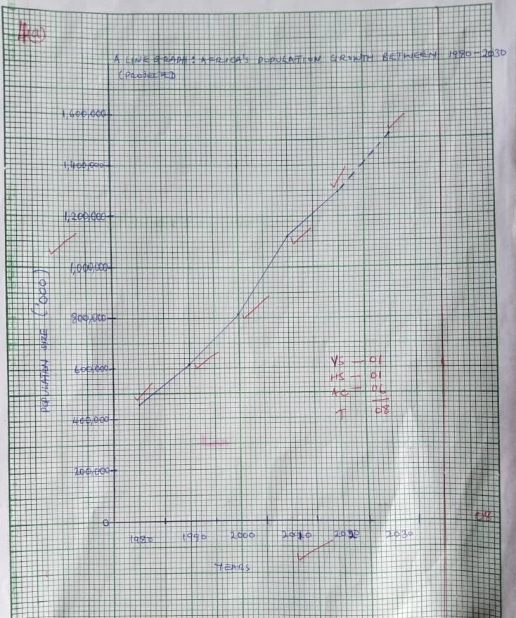4 (a) **A LINE GRAPH; AFRICA’S POPULATION GROWTH BETWEEN 1980 – 2030**

4 b (i) Describe the trend of Africa’s population grow between 1980 and 2030

* Between, 1980 – 2010 was a high steady increase.
* Between, 2010 – 2020 was a low steady increase
* Between, 2020 – 2030 was an expected (projected) high steady increase. Max 2 marks

4 b (ii) State the period in which Africa experienced the.

* Highest
* Lowest

Percentage increase in population.

Calculation (s) of percentage increase;

Period Percentage increase

1980 – 1990 (616,411 – 453, 390) x 100 = 35.96%

453,390

1990 – 2000 (818,099 – 616,411)/616,411 × 100% = 32.71%

2000 – 2010 (1123508 – 818,099)/818,099 × 100% = 37.33%

2010 – 2020 (1296777 – 1123508)/1123, 508 ×100% =15.42%

2020 – 2030 (1524645 – 1296777)/1296777 × 100% =17.57%

Therefore period with highest percentage increase: 2000 – 2010

Lowest percentage increase: 2010 – 2020. Max 4

4 (c) Explain, using specific examples, the factors which have led to a high population growth rate in Africa.

* High birth rates in Nigeria, Egypt, South Africa, etc. i.e. the number of live birth per 1000 members of the population in a year.
* High fertility rates of women and men. The fertility rates of women from sub Saharan Africa tend to fall in the range of 5.7 children per woman hence a high natural increase in population.
* Declining death rates due to improved medical service e.g. in South Africa, Nigeria, etc. Vaccination campaigns have helped lower death rates among children from killer diseases like hooping cough, measles.
* Early marriages e.g. as experienced during the pandemic of Covid 19 in most African countries like Zimbabwe, South Africa, Nigeria making young girls have a long reproductive period.
* Polygamous practices among many Africa tribes like South Africa, Lethoso, Nigeria lead to the marrying of many wives who produce many children per family.
* Religion practices like allowing polygamy among Muslims in Egypt, Nigeria and discouragement of artificial birth control measures by the Catholics of Ethiopia, South Sudan, South Africa, and DRC all contribute to high population growth.
* Improved nutrition level due to favourable climatic conditions of hot and wet conditions and fertile soils in Nigeria, Nile basin of Egypt which allow the growing of more food to support the increasing population.
* African societies have traditionally seen large families as signs of wealth, prestige and therefore valve the presence of children in everyday life e.g. in Nigeria, South Africa, and DRC.
* Immigration into Africa mainly in South Africa, Ethiopia from Asia (Indian and Chinese) and Europe (Dutch, England) over the years has contributed to African’s population growth.

1d – max 03 marks

Ex max 03 marks

(06 marks)

**NOTE**; for ex should only be awarded when a specific example of an Africa country is cited.

4 (d) outline the disadvantages of a large population size in Africa.

* Land shortage leading to land disputes, land fragmentation resulting in death, decreased crop yields.
* High dependency ratio reducing savings and investments for future development.
* Over cultivation of land resulting in loss of soil fertility hence lower crop yields.
* Deforestation is carried out to create room for settlement and farming resulting in soil erosion, landslides and reduced rainfall.
* Congestion leads to easy spread of diseases like cholera, typhoid, STDs and cough.
* High rates of unemployment as the rate of population growth far exceeds the rate of job creation.
* High crime rates like murder, robbery and prostitution due to unemployment.
* Inadequate accommodation for the large population resulting in the development of slums and their associated evils.
* Wide spread poverty due to too many people compared to the available resources.
* Shortage of food resulting in hunger, starvation and famine.
* Encroachment of marginal lands e.g. game and forest reserves, reclamation of wet lands for settlement and agriculture.
* Pollution of the environment due to improper wastage disposal.
* High cost of living due to increased demand for goods and services. Max 04 marks

(25 marks)

5 (a) Name: (i) Lakes A – Superior

C – Erie

Ocean F – Atlantic

(ii) Feature at; B – Sault St. Marie or Soo canal

E – Naigara Falls/Welland canal/locks

Rapids 3 – St Lawrence rapids.

(iii) River/Strait 4- St Claire Detroit. (05 marks)

5 b(i) Describe the (i) aims of construction of the Great Lakes and St. Lawrence Sea way.

* To open up the interior of North America to facilitate the extraction of minerals such as iron ore and lime stone as well as agricultural resources like wheat from the prairies of Canada.
* To create deep water navigation from the productive interior of North America to the Atlantic Ocean. Bottle necks, islands, falls, fluctuation in water level floods had to be addressed.
* To generate hydro – electric power that was expected to increase the level of industrial development in the area. 1d – 03 marks

ds – 03 marks 6 marks

5 b(ii) The operation of any one navigational locks along the St. Lawrence sea way.

Locks; Welland canal and locks

Iroquois dam and locks

Any one 1 mark.

* Locks are very impressive lift systems. A lock is a stretch of water closed off by gates so that the water level can be raised or lowered to move vessels up or down. Ships measuring up to 226 meters long, carrying cargo equivalent to 25,000 metric tonnes are raised to 180 meters above sea level.
* The lock has lock gates and sluice gates. The lock gates are used for the passage of the ship into or out of the lock. The sluice gates allow water in or out.
* If the ship is to sail from a lower level of water to a higher level, the lock gates at the lower level are closed after the ship is inside the lock. The sluice gates here are opened and water flows in. Each lock can fill with about 91 million litres of water in about 10minutes.
* The water will keep rising until it is at the same level that of the higher section. The lock gates are then opened to allow the ship to move out and continue with its journey. It takes about 45 minutes for a ship to go through a lock. Small trains called mules are used to pull the ship passed the lock section. Max 5 marks

5 (c) Explain the contribution of the Great takes and St. Lawrence sea way project to the development of U.S.A and Canada.

* Opened up the interior of U.S.A and Canada providing cheap water transport.
* An important export route for agricultural and industrial output bringing in foreign exchange.
* Stimulated industrialization e.g. Duluth, Toronto, Port Arthur.
* Encouraged exploitation of natural resources e.g. coal from Pitts burg, iron ore from Quebec.
* Generation of HEP at Barn hort for industrial and domestic use.
* Generation of employment opportunities, work on ocean going vessels, earning income.
* Promoted trade earning people income hence raising Standard of living.
* Generation of revenue through tariffs/tax levied on vessels for infrastructure development social welfare.
* International relationship/togetherness through construction of the sea way hence promoting trade.
* Promoted direct transportation of goods to the Great lakes without trans-shipping their goods, hence reduction in transport and trading costs.
* Flooding and its related problems have been solved by construction of dams, canals etc.

1d – 03 marks

Ex – 03 marks (06 marks)

5 (d) Outline the environment problems resulting from the establishment of St. Lawrence sea way project.

* Traffic congestion at the ports causing delays.
* Pollution of air, water, land by and oil spills that destroy the quality of water affecting aquatic, tourism and human life.
* Water weeds block turbines and water ways.
* Low visibility caused by smog and fog that accumulate from fumes from vessels, industries.
* There are problems of sea pirates/terrorists.
* Destruction of marginal lands/swamps leading to loss of natural beauty/floods.
* Development of slums leading to poor sanitation and easy spread of diseases.

Max (03 marks)

6. a (i) Calculate the missing valves to complete the table above.

Taxas: × 3600 = 1080

Mississippi: × 3600 =360

New mexico and Arizona: × 3600 =360

Others: × 3600  =900 max (02 marks)

6. a (ii) One state with the least relative importance of cotton production in the Southern U.S.A.

Either – New Mexico.

OR – Arizoxa (01 mark)

6. (b) A PIE CHART SHOWING THE RELATIVE IMPORTANCE OF COTTON GROWING

IN SELECTED STATES OF SOUTHERN U.S.A

6. (c) Explain, using specific examples, the factors which led to the decline in cotton production in the old cotton belt in Southern U.S.A (example could be states in old, New cotton belts, policies, pest, factors, etc.)

* The growing of one crop i.e. cotton year after year/mono culture led to soil exhaustion and ultimately lower crop yields; Mississippi, New Mexico, Arizona, Oklahoma, Louisana, Albama, Georgia, S.Carolina.
* Soil erosion due to inadequate soil cover provided by the cotton crop; neglect by share croppers resulted in a decline in cotton yields in Georgia.
* The cotton ball weevil infested the South areas i.e. Albama, S.Carolina and thrived best in the warm and humid climate there. This resulted in the decline in cotton production; increased production costs.
* Frequent occurrence of strong winds/hurricanes e.g. Catherina on the eastern side – S.Carolina destroyed cotton plants.
* Shortage of labour to work on the plantations as slaves who had previously provided labour had been freed and migrated to the West – California, Arizona; Joined better paying jobs in emerging industries.
* New crops were introduced to renew the exhausted soils e.g. beans, maize, tobacco. This reduced the acreage of land under cotton.
* Introduction of synthetic fibres like nylon, polyester in U.S.A and the world market reduced the demand for cotton
* The low prices and incomes earned from the cotton discouraged the farmers and many abandoned cotton growing.
* The cotton fields in some area like Albama, Arizona were replaced with pasture to feed the cattle introduced on the farms reducing cotton acreage.
* Government policy of compensating farmers for using their land previously under cotton for other purposes like planting trees and setting up ranching schemes reduced cotton acreage and output.
* Opening up drier western areas e.g. California for cultivation of cotton through irrigation ensured production throughout the year, hence a decline in cotton production in the East that depended on nature. 1d – max 04 marks

ex – max 04

08 marks

6. (d) Outline (i) the effects of cotton growing on the environment in the Southern U.S.A.

**POSITIVE EFFECTS.**

* Generation of employment hence income and raising Standard of living.
* Raw material for agro based industries e.g. textiles.
* Market for industrial goods like fertilizers, machinery
* Urbanization due to emergence of processing industries.
* Infrastructure development e.g. road, schools; dams, canals,
* Source of foreign exchange through cotton export.
* Floods have been controlled through construction of dams.
* Promotion of international relationship promoting trade, tourism
* Diversified economy reducing over relying on sectors like film, service, manufacturing; broaden source (s) of income/revenue

**NEGATIVE.**

* Soil exhaustion due to over cultivation of the land.
* Pollution of soil and nearby water bodies through excessive use of fertilizers; pollution air through cotton processing industries.
* Soil erosion occurs due to the inadequate soil cover.
* Cultivation of cotton near rivers leads to siltation.
* Loss of natural vegetation cover through wide spread destruction of forests to create room for large cotton plantation.
* Landslides caused by clearing of vegetation from highlands.

Any 4 (04 marks)

6. d (ii) Measures that should be taken to have the negative effects of cotton growing on the environment in the Southern U.S.A.

* Bush following should be done to enable soils regain fertility.
* Treating industrial wastes before releasing them to atmosphere; use of farm yard manure instead of industrial fertilizers, limit pollution should be done.
* Cover crops like legumes should be planted to control soil erosion.
* River banks should be protected by planting grass a long them to mitigate siltation of rivers.
* Afforestation and reforestation should be done to protect land against soil erosion and landslides.

Max 4 (08 marks)

Total (25 marks)

7. (a) Draw a sketch map of British Columbia and on it, mark and name any two;

(i) Rivers;

(ii) Interior timber collecting centres;

(iii) Coastal timber collecting ports;

(iv) Pacific ocean.

**BRITISH COLUMBIA: RIVERS, COASTAL PORTS AND INTERIOR TIMBER COLLECTING CENTRES**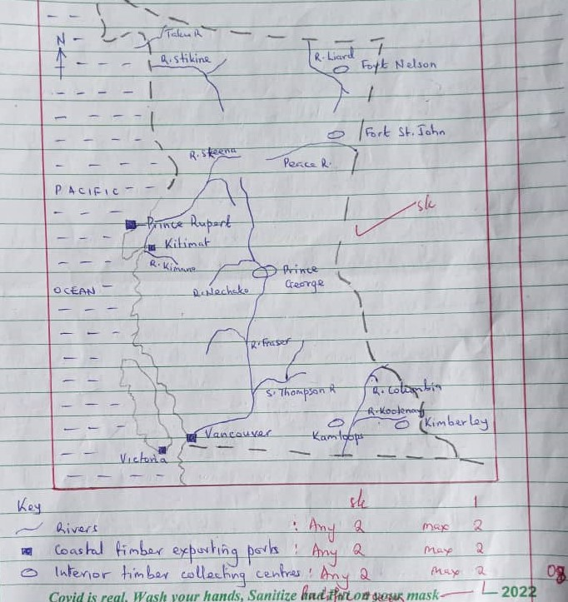

7. b (i) State any two tree species found in British Columbia.

* Douglas fir
* Cyprus
* Western hemlock
* Western red cedar
* Spruce
* Balsam fir
* Pine

Any 2 (02 marks)

7. b (ii) Describe the characteristics of forests found in British Columbia.

**Coniferous forests that cover 96% of the total forests area.**

* The trees occur in pure stands i.e. a single species of trees can occur over a very large area.
* The trees are tall, straight and slander; because are very close together.
* The trees have flexible trunks which bend easily with the wind which is sometimes quite strong.
* The trees have small needle shaped leaves. This is to prevent excessive loss of water by transpiration.
* The tree leaves have a wax – covering surface and a thick leathery structure to protect the leaves from pest attack.
* The trees consist of mainly soft wood species.
* The trees are fast growing, maturing in ten to twenty years.
* The trees form hard cones instead of fruits which are difficult to peel. The cones consists of scales close tighter and seeds which are thick – coated.
* They are ever green throughout the year to safe guard against pests and harsh conditions like fires, drought.
* The trees have a conical shape with branches sloping down word. This helps to prevent excessive snow accumulation which could have caused the branches to snap or break.
* The trees grow close to each other forming a moderate density.
* The trees have shallow roots to survive the thin soils and frozen ground in winter.
* They are located in high altitude.
* Located in the high latitudes or temperate lands.
* Limited undergrowth as there is little leaf fall to enrich the soil. The decayed ‘needles’ yield acidic soil unfavorable for plant growth; also less or no sunlight penetration to allow photosynthesis of the could be under growth.
* Trees form a single canopy.

**Deciduous and mixed ever green forests;** cover 4% of the total forest area of British Columbia.

* Located in low altitude
* Yield fruits
* Many species
* Have umbrella shaped with 3 canopies
* Have buttress roots to support their great weight
* Dominated by hard/heavy woods; tick
* Impure stand
* Have broad leaves
* Leaves shed off at different times and sprout at different times hence ever green.

**NOTE**: No forest type stated, no mark for the characteristics.

Forest type: 1 mark

Characteristics max 4 marks

7. (c) Explain, using specific examples, the physical factors which led to the development of the forestry industry in British Columbia.

* Much of British Columbia consist of rugged mountainous land scape e.g. the Rocky mountain in the East and Coastal ranges in West discouraging agriculture and settlement hence leaving space under forests.
* Wide variety of tree species of commercial value e.g. Douglas fir, pine, spruce that are profitable to exploit.
* Temprate climate consisting of wet and warm summers and cold dry winter favour the growth and harvesting/transport of the tree, and logs respectively.
* Most areas have thin infertile soils unable to support agriculture but support forests south west near Kimberley.
* Presence of snow during winter, which helps in the transportation of logs by sliding, them over snow surface.
* Presence of rivers like traser, skeena used for floating logs down to the coastal areas for processing at saw mills.
* The coniferous forests occur in pure stands making it easy to cut the trees.
* The logs are light in weight hence easy to transport to local and foreign markets.

**NOTE**: No mark (s) for human factors,

1d – 04 max

Ex – 04 max (08 marks)

7. (d) Outline the problems facing the forestry industry in British Columbia.

* Fire out breaks are wide spread in summer and destroy large areas of valuable forestland
* During severe
* winters, the whole land is covered by deep snow bring lumbering activities to a standstill.
* Over-exploitation/ depletion of easily accessible coastal and off shore island forest – Vancouver.
* The regged terrain restricts forest accessibility and the development of transport routes e.g. the Rocky and Coastal ranges.
* Shortage of labour to fell, buch and yard logs due to the sparse population.
* Accidents occur during felling of the trees leading to the death of workers.
* High transport costs incurred in transporting timber products to far markets of Europe reducing profit.
* Large masses of ice (avalanches) move downhill and destroy large areas of forestland.
* Severe competition from New Zee land where trees grow faster than in British Columbia.
* Some trees like the Dougles fir have a long gestation period thus limiting regular supply of such logs and timber.

8. (a)

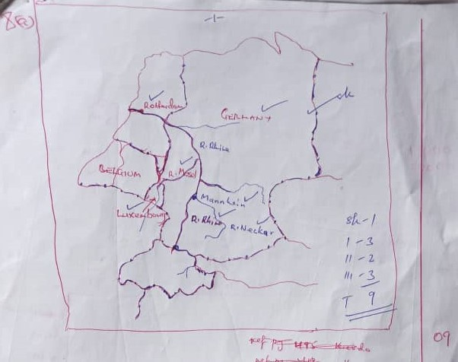

8. (b) Describe with specific examples the conditions that have favoured the development of;

**PORT ROTTERDAM**

* It is strategically located within close proximity of the North Sea which is one of the busiest international sea routes to USA, Canada and Africa.
* Its strategic location on the Rhine R has made it an entire port to the countries served by the river such as Switzerland Germany and Luxembourg.
* Presence of deep water being an estuary enabling large ships to enter and leave the port without any danger.
* Presence of well sheltered natural harbor protecting the port from the hard hitting North Sea waves.
* Presence of a low tidal range hence allowing large boats to anchor.
* Presence of vast land for expansion of loading and off-loading cargo, construction of other port fertilities.
* Presence of the North Atlantic drift, a warm current which helps to keep the port ice free throughout the year.
* The topography is relatively flat and wide for easy construction of transport systems and for expansion of port facilities.
* The rapid growth and development of industries which requires bulky raw material and the need to export industrial products abroad e.g. ship – building, mineral oil refining.
* Presence of highly skilled labour force to construct the port facilities and handle port business.
* Advanced technology which has enable the construction of a deep water channel known as the New Water way and several canal which provides access by deep – ocean going vessels between the port and the North sea.
* Availability of large sums of capital for the construction of the New Water way and port facilities.
* Supportive government policy like developing the port to international standards.
* Availability of adequate and varied power resources in form of petroleum, HEP, coal and natural gas for use at the port. 1d – 03 max

Ds – 03 max

06 marks

8. (c) Explain the contribution of port Rotterdam to the development of the Rhine basin.

* The port has stimulated agricultural and industrial development in the region by availing cheap transport for bulky as well as finished goods.
* The port has boasted import and export trade through the provision of cheap transport and handling facilities for minerals, industrial and agricultural goods.
* It has provided employment opportunities to various people in construction and maintenance of port facilities, handling cargo, ship building and establishment of industries.
* Income earned from the various port facilities have helped to improve the people’s Standard of living
* The port has promoted international cooperation between the Netherlands and other countries like Switzerland, Germany that use the port.
* The port has generated revenue for Netherlands used for economic development.
* Contributed to growth of inland ports e.g. Mannheim, Koblenz, Base and Dusseldorf.
* The port provides a large in let for goods and services produced in the refioc
* Has encouraged development of infrastructure like roads, railway, canals and power generating facilities.

1d - 03 max

Ex – 03 max (06 marks)

8. (d) Outline the problems resulting from the development of Rotterdam port.

* Pollution of the environment through oil spills from ships, industries as well as noise pollution.
* Limited land for expansion of the port facilities.
* Traffic congestion causing delays since it’s the busiest port.
* Fog and smog reduced visibility leading to accidents.
* Overcrowding due to too many people causing easy spread of diseases like T.B, COVID 19.
* The area is prone to floods since it is located in a low lying sea much of it found below sea level.
* There is silting of river channels especially R.Maas and the New Waterway.
* Development of an urban centre with its associated problems of shortage of housing, unemployment and high crime rates.
* High cost of maintenance of port facilities.

(25 marks)

9. (a) A COMBINED LINE AND BAR GRAPH: CLIMATE OF LUGANO SWITZERLAND.

(276 m)

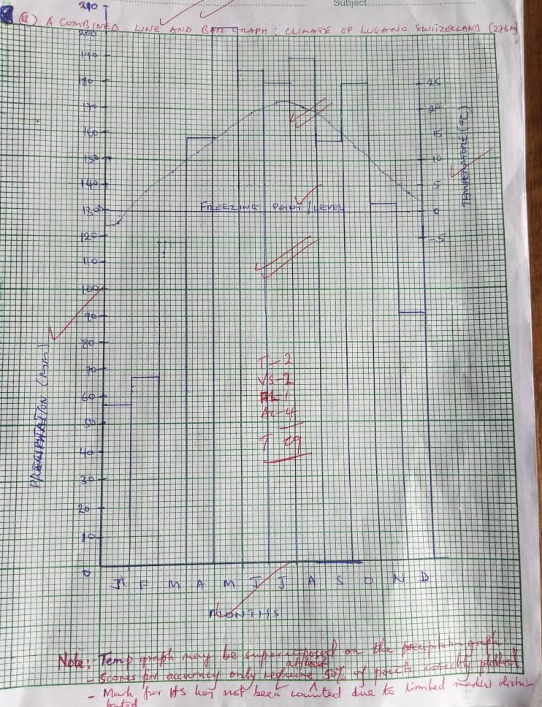

**NOTE:** Temperature graph may be super-imposed on the precipitation graph.

* Scores for accuracy only require at least 50% of points correctly plotted.
* Mark for HS has not been counted due to limited marks to be distributed.

9. (b) Describe the characteristics of the climate of the station.

* Mean annual temperature is 1370c/12 = 11.40c; which is warm.
* Mean annual rainfall is 1725mm; which is very heavy.
* The monthly rainfall is at least wet throughout the year; wet and very wet.
* The annual temperature range is =23.60c; very large.
* The month with the lowest temperature is January; -2.30c which is cold.
* The month with highest temperature is July (21.30c) which is hot.
* The warm months are April, May, June, September and October (100c ˂200c)
* The hot months are July and August (≥200c).
* The cool months are February, March, November and December (0˂100c)
* The month with the highest monthly rainfall amount is March (203mm which is very wet)
* Presence of thick cloud cover throughout the year at least wet throughout the year.
* Relative humidity high July and August (hot temperature) enhance high evaporation and transpiration.
* Relative humidity moderate – April, May, June, September, and December (warm temperature) enhance moderate evo-transpiration.
* Relative humidity is low – November, December, January, February and March (temperatures are cool) enhance low evo-transpiration.
* Low atmospheric pressure most of the year i.e. from April – December that draws in rain-bearing heavy wind causing at least wet conditions.
* Station experience a single rain fall maxima/mono – modal pattern of relief distribution.

**NOTE**; Sweeping statements attract no scores or marks

Stated characteristic (s) should carry an appropriate adjective describing it. Max 5 marks

9. c (i) Explain the influence of climate on the economic activities in c (i) above.

* Due to heavy rainfall received montane/coniferous forests have grown thereby promoting lumbering.
* The south – facing area of Lugano receive adequate sunshine attracting arable farming mainly the growth of orchards and vines.
* The heavy mean rainfall received favours the growth of fodder crops that are used for animal feeding.
* The high altitude areas that have low temperature of below freezing point lead to permanet snow cover hence attracting tourism e.g. ice skating.
* The heavy rainfall received causing permeant source of water transport on L.Lugano.
* Heavy rainfall promote forest growth that attract wild animal’s hence game hunting.
* The modified meditarranean has mild climate due to influence of the high pressure conditions attract a range of activities: animal rearing.
* The climate that promote arable farming result into agro-based processing industries e.g. dairy processing factories, maize and wheat factory etc.

1d – 3 max

Ex – 3 max (06 marks)

9. (d) Outline the problems faced by the people carrying out the economic activities in c (i) above.

* Soil erosion as a result of very heavy rainfall and steep slopes; loss of fertility.
* Soil leaching due to heavy rainfall leading to loss of soil fertility.
* Flooding during wet and very wet seasons; affecting crop, pasture, transport negatively.
* Pests; destroy orchards and vine yards.
* Diseases; COVID 19; foot and mouth diseases to livestock. Max 03 marks

**Note: problems must clearly be attached to the given economic activity.**

10. (a) Name the;

(i) Physiogrophic regions marked: W – Uplands

X – Lowland (02 marks)

(ii) Rivers marked: C – Alzette River

D – Moselle River (02 marks)

(iii) Industrial towns marked; 1 – Differdange (dudelange) (01 mark)

2 – Luxembourg city (01 mark)

(iv) Country marked 3 – France (01 mark)

10. b (i) State any one type of industries found in each industrial town named in (a) (i) above.

|  |  |
| --- | --- |
| **Town** | **Type of industries** |
| Alzette  1 | Iron and steel  Food processing (01 mark) |
| Differdange | Iron and steel  Food processing chemical and metal fabrication (01 mark) |

10. b (ii) Describe with specific examples the factors which have led to the development of industries in Luxembourg.

* Presence of adequate raw materials like iron ore from the South western corner of the country at the border with France and agricultural raw materials.
* Well development transport and communication routes by road, railway and air water in R. Mosselle to link industries to source of raw materials.
* Highly skilled labour force to work in industries.
* Larger market for the industrial goods in the neighboring rich European countries.
* Attraction of rich foreign visitors e.g. the General motors to invest in manufacturing industries.
* Advanced technology used involving automation of industries creates efficiency and results in economies of large scale production
* Presence of a ready supply of power especially HEP to run the industries.

1d – 03 max

ds – 03 max (08 marks)

10 (c) Explain the importance of the industrial sector to the development of Luxembourg.

* Provided employment opportunities to citizen earning their income and to raise their Standards of living.
* Encouraged development of infrastructure like roads, canals railway lines which facilitate movement of people and commodities.
* Income earned is used to raise people’s standard of living.
* Government source of revenue through taxing industrial products, incomes of industrial workers which is used for infrastructure development.
* Industrial products are exported to EU earning the country foreign exchange for development of infrastructure or importing what is not produced in Luxembourg.
* Promotion of international relationship hence promoting trade and political togetherness and stability leading to increased production.
* Provide inputs for agriculture sector e.g. tractors, fertilizers, hence enhancing agricultural productively.
* Industries have resulted into urbanization and associated advantages such as development of social – economic infrastructure. 1d – max 03

Ex – max 03

10. (d) Outline the effects of the industrial sector on the environment.

* Pollution of air water, land through untreated industrial waste into atmosphere from the industries causing respiratory diseases like asthma.
* Exhaustion/depletion of minerals that are used in industries like coal left ghost factories.
* Industration has encouraged conurbation with evils like prostitution, slum development.
* Competition for land between agriculture, industries result into displacement of people.
* Traffic conjestion leading to delays in the transportation of goods and services
* Accidents in industries leading to lose of lives.
* Destroying the landscape and encroachment on marginal swampland, for establishment of industries affecting bio-diversity.
* Global warming due to the release of greenhouse gases into the atmosphere. Max 04 marks

11. (a) **SKETCH MAP OF CHINA SHOWING WATER BODIES AND TWONS.**

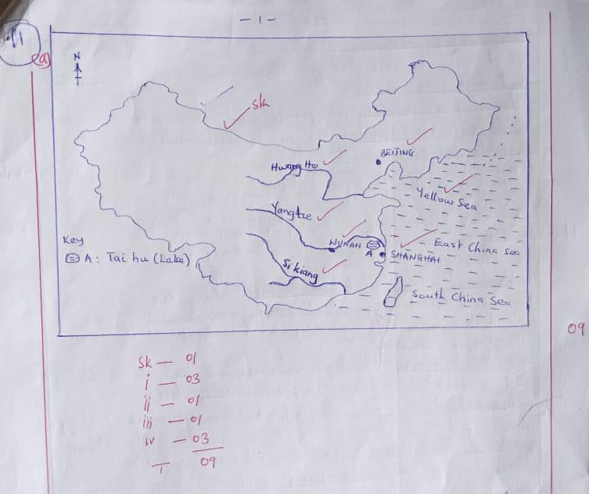

11. (b) Describe the steps being taken in china to develop the Si – kiang River basin:

* Construction of stone/Concrete barriers along river banks to control floods and their destructive effects.
* Construction of canals and channels to divert excess river water into farmland and resources for use at later time.
* Planting cover crops near the river to control siltation caused by erosion from the nearby land.
* Maximum exploitation of available land e.g. the narrow dykes that divide the rice paddies are planted with sugarcane and mulberry trees.
* Use of organic manure and fertilizers to enhance soil fertility for better crop yields.
* Practicing land consolidation to enhance extensive farming and ensure large scale crop production.
* Carrying out intensive research for high yielding crop varieties and better animal breeds.
* Spraying of affecting crops with pesticides to limit spread of pests and diseases in the farms to ensure quality produce.
* Swamp reclamation to increase equitable land distribution.
* Green houses – regulate extreme weather condition of winter.
* Irrigation – Summer, expansion of produce.
* Encouraging co-operation amongst agro – commune workers which can be reflected in their commitment to work and high crop yields.
* Use of fresh water from rivers and harvested rain water to de – salinate/ dissolve the saline soil and make it suitable for crop growth.
* Promotion of fishing in marine and fresh water
* Promotion of road railway inland and see transport; canals e.g peh – kiaugsu
* Promotion of industries.
* Weather forecast and working e.g. typhoons, hurricanes.
* Promotion of Tungsten mining near, Houg key, tin and cu (kumming)

1d - max 03

ds - Max 03

11. (c) Explain the contribution of the Si – Kiang River basin to the development of China.

* Urbanization and related advantages along the river valley/basin and market centers like Nanning, Hanio, Canton Standards of living.
* Industrialization – agro-processing for both local and foreign markets Hong Kong, employment.
* Government revenue through taxes and licenses levied on the forests and agricultural industries, infrastructural development.
* Encouraged economic diversification through crop farming, mining, industrialization, fishing hence broadening the sources of income and revenue collection; over dependence on a few sectors.
* Creation of many employment opportunities to the farms, transporter earning them income hence improving their standard of living (Living a meaningful life)
* Increased food supply to the community e.g. wheat, rice and potatoes which improves on people nutrition and food security.
* Earning of income to farmers through sale of produce thus improving their S.O.L by accessing basic needs of life.
* Earning of foreign exchanges through export of agro – products to the world market thus boosting the economy.
* Infrastructural development e.g. railway like Canton – peking – Kweilin that enhances economic development.

1d – max 03 marks

Ex – max 03 marks

(06 marks)

11. (d) Outline the negative effects of agriculture on the environment in the Si – kiang River basin.

* Destruction of vegetation cover to create land for cultivation and grazing.
* Compaction of soil due to use of heavy machinery making the ground hard to plough and cultivate, and limits water percolation into the soil.
* Soil erosion leading to gullies caused by clearing of vegetation which in turn wastes away soil nutrients.
* Pollution of the soil due to excessive use of chemicals and fertilizers that changes the soil ph making it acidic thus limits crop growth.
* Salination due to continuous irrigation along the coastline and delta exposing salt components in the cultivable land.
* Siltation of the rivers due to cultivation along the river balks that exposes soil to erosion hence deposition of allauium and other sediments into the river.

Max – 04

(25 marks)

12. (a) Name the

(i) Rivers marked A: Yalu River

B: Yellow River/ Hwang – ho

(ii) Gulf marked X: Bo hai

(iii) Towns marked 1: Nanjing

2: Baoji

1. Railway lines marked C: Beijing – Shanghai railway

D: Beijing – Shenyanga railway

(07 marks)

12. (b) Describe the conditions which led to the growth of Beijing as an urban Centre.

* Its strategic location on the banks of River Yalu/Liao – he which links it to rich the hinterland.
* Presence of deep and well drained alluvial fertile soils for crop cultivation and animal husbandry on the North china plain.
* The historical factor of being protected from invaders by the Great wall that attracted many inhabitants to the area.
* The existing ice free conditions due to the warm air masses from the desert lands of the west that enabled the practice of a variety of economic activities.
* Presence of advanced/appropriate technology used in the setting up basic infrastructure and related facilities that enhance the access to basic needs of life.
* The city was situated at the center of early chinese civilization near the Yellow River where man settled and developed great trade links and infrastructure.
* Existence of relatively flat land (North China plain) suitable for human settlement and infrastructure development in the area.
* Supportive government policy of setting up a capital city for administration functions that could be used as a base for effective governance of the country.
* Political stability that attracted both domestic and foreign traders and dwellers into the city.
* Efficient transport and communication networks linking the city to other parts of China and the world it large hence making it accessible.

1d – max 03 marks

D2 – max 03 marks

(06 marks)

12. (c) State the functions of Beijing City;

* A trade and business center with major shopping malls, etc.
* A cultural center with palaces, temple, galleries, the great well, forbidden city, temple of heaven, etc.
* An industrial center and with a number of manufacturing and processing industries.
* A transport and communication center with subways, railways, canals, air ports, roads etc.
* A tourist center with chines architecture and other natural features.
* An administrative center acting as the national capital.
* A residential center with banks, insurance companies, clearing and forwarding etc.
* A leisure and entertainment center with opera houses, theatres.

12. (d) (i) Explain the problems faced by Beijing City.

* Pollution of air, land and water by the existing industries and human waste that is not properly disposed off.
* Low level of having affordability among the populace due to low disposable income and limited lowing facilities due to the dense population.
* High crime rate e.g. robbery due to limited job.
* Reduction in green space/zones due to increasing need for land to set up infrastructure to cater for increasing population.
* Occurrence of floods due to being situated in diverse drainage area and also earth quakes due to being near the Pacific Ocean ridge susceptible to continental drifling.
* Difficulty in securing adequate and reliable water due to increasing population and industries.
* Health risks arising from pollution/smog that cause inhalation diseases and cancer related ailments.
* Occurrence of traffic congestion causing delays in departure and delivery of goods, services and passengers.
* High energy demands due to dense population that uses the energy for domestic needs, industrial and transportation.
* Land shortage for expansion of plastic infrastructure and private activities.

1d – max 02

Ex – max 02

12. (d) (ii) Outline the steps being taken to solve the problems in d (i) above.

* Building of slay scrapers to increase the housing capacity of the city.
* Strick legislation on migration to the area to enhance planning and proper usage of infrastructure.
* Time – tabling travel or following exiting schedules to regulate congestion and effective transfer of goods and passengers.
* Treatment of workers/recycling them so as to control pollution.
* Constrict underground tune, bridges, fly overs that law helped to ease ocean to the island.
* Tapping other energy sources like solar, nuclear.
* Construction of dykes to safe guard against floods.
* Construction of buildings with shock – absorber technology to reduce impart caused by earthquakes.
* Tightening security, eliminating drug addicts, criminals; police.

13. (a) A COMBINED LINE GRAPH SHOWING ANNUAL COPPER ORE PRODUTION

AND CONSUMPTION IN CHINA BETWEEN 2010 AND 2025 (PROJECTED)

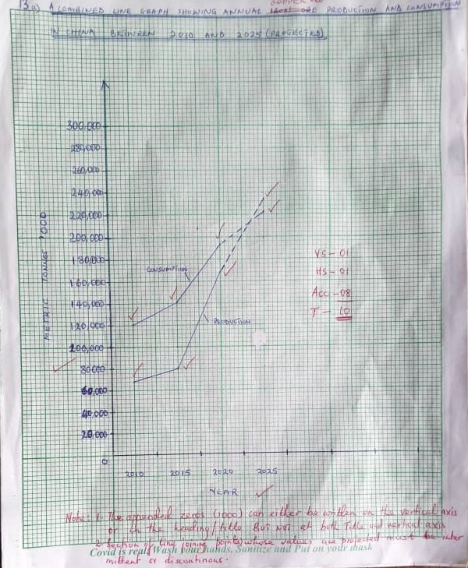

NOTE: 1. the appended zeros (000) can only be written on the vertical axis.

2. Section of line joining points whose values are projected must be intermittent or

discontinuous.

13. (b) Describe the

(i) Trend of production.

* Between 2010 and 2015 there was a slight increase in copper ore production in China;
* Between 2015 and 2020 there was a sharp increase in copper ore production in China.
* Between 2020 and 2025 there is an expected (projected) sharp increase in copper ore production in China. Max 02 marks

(ii) Trend of consumption.

* Between 2010 and 2015 there was a slight increase in the consumption of copper ore in China.
* Between 2010 and 2020 there was a sharp increase in copper ore consumption in China.
* Between 2020 and 2025 there is an expected (projected) slight increase in copper ore consumption in China. Max 02 marks

(iii) Relationship between production and consumption of iron ore in China between 2010

and 2025.

* Between 2010 and 2015 consumption was much more than production of copper ore in China.
* Between 2015 and 2020 the gap between consumption and production of copper ore progressively become smaller in China.
* Between 2020 and 2025 production is expected (projected) to outstrip/surpass/more than consumption of copper ore. Max 02 marks

**NOTE:** Period, magnitude of change should all be reflected in the given answer.

13. (c). For any **one** area where copper ore is mined in China explain the factors which have favoured its production.

Areas:

* Lanzhou, Hwetsech, Kweicpon
* Changsha, Weining, Szechwan
* Kunming, Tiepaoshan, Yonki, Kirin
* Yunnan, Lanchaw, Shanxi, Yulong, Beiya etc. max 01 mark

**Presence of;**

* Rich copper ore reserves that facilitated copper exploration and exploitation.
* Adequate capital provided by the government and foreign investors that enabled copper survey, exploitation and processing.
* Modern technology like open cast and shaft mining methods that was used to extract copper from underground.
* Continuous research to enhance exploitation and processing of copper to meet the increasing leads of the people and industries.
* Increased demand for copper by domestic industries to make bronze, coins to enhance economic development.
* Fairly developed access routes like railway, water way that enable the transfer of heavy ore and workers from the miles respectably.
* Regional policy of ensuring self – sufficiency in the respective regions of China and reduce dependence on the central government.
* Large semi and skilled labour force that earlier settled in the Manchuria and Inner Mongolia plains coupled with immigrants from Russia that work in the copper.
* Integration of mining copper and industrial sector by government to enhance inter-sectoral development and maximize output from the available resources.
* Abundant energy supply from HEP, Coal, nuclear used for copper smelting in the area.
* Positive government policy for mining copper that aided at using underground resources for the well-being of the people. 1d - 02 max

Ex – 02 max

(05 marks)

13 (d) Outline the contribution of copper ore mining to the development of China.

* Abundant and cheap supply of copper used as a raw material for copper based industries.
* Employment opportunities to the people earning them income thus improving their well-being.
* Utilization of waste land/desert land that would have been idle yet rich with copper resources.
* Infrastructure development like roads, railways in remote areas that had copper potential yet with less development.
* Promotion of international relationship and trade relating to copper ore and copper related products.
* Earning of foreign exchange by the government through export of copper to other countries which in turn is used to develop other sectors.
* Source of government revenue through taxation of the copper ore mining and used in social development etc. max – 03 marks

**E N D**